Part 1: Local Environment Setup
All the commands in the following process are executed in the Visual Studio Code Terminal.

1. Cloning the Repository
git clone https://github.com/openai/point-e.git
cd point-e

2. Setting Up Virtual Environment
Using a virtual environment to manage dependencies:
python -m venv venv
.\venv\Scripts\activate # On Windows

3. Installing Dependencies
Installed required dependencies along with Open3D:
python.exe -m pip install --upgrade pip
pip install -e .
pip install open3d==0.19.0

4. Verifying Installation
To confirm a successful installation:
python -c "import point_e; print('Point-E installed successfully')"

5. Challenges Encountered & Resolutions
- Missing Libraries:
  - Resolved by manually installing required dependencies.
- Version Conflicts:
  - Faced issues with torch and numpy version compatibility.
  - Resolved by pinning compatible versions:
pip install numpy==1.23.5
python -m pip install torch torchvision torchaudio --index-url https://download.pytorch.org/whl/cpu
- JupyterLab Installation:
  - Installed to provide an interactive development environment:
pip install jupyterlab
pip install notebook ipykernel
Run command: jupyterlab
- Visualization Tools:
  - For viewing .ply files and 3D point clouds:
pip install trimesh

Part 2: Running a Minimal Example

1. Executing Text-to-Point Cloud Generation
- Ran text2pointcloud.ipynb using JupyterLab with the prompt:
prompt = 'a red motorcycle'
- Successfully generated a 3D point cloud of a red motorcycle.

Observations:
- Runtime: ~28 minutes for 130 iterations on CPU.
- GPU Usage: Unavailable due to driver issues.
- Output: Displayed multiple 3D views of the generated point cloud.

2. Executing Image-to-Point Cloud Generation
- Ran image2pointcloud.ipynb using JupyterLab with the input image:
example_data/cube_stack.jpg
- Successfully generated a 3D point cloud of stacked cubes(a red cube on top of a blue cube).
Observations:
- Runtime: ~48 minutes for 130 iterations on CPU.
- GPU Usage: Unavailable due to driver issues.
- Output: Displayed multiple 3D views of the generated point cloud, accurately reflecting the spatial arrangement of the cubes.

3. Issues Encountered
- NVIDIA GPU Driver Issue:
  - Error:
No NVIDIA GPU is detected on your system.
This graphics driver could not find compatible graphics hardware.
  - Root Cause: No compatible NVIDIA GPU on the system.
  - Resolution: Ran the example on CPU instead.
  - Next Steps:
    - Explore alternative drivers for GPU acceleration.

4. Proof of Successful Run
- Output Screenshots: Text-to-Point Cloud Generation
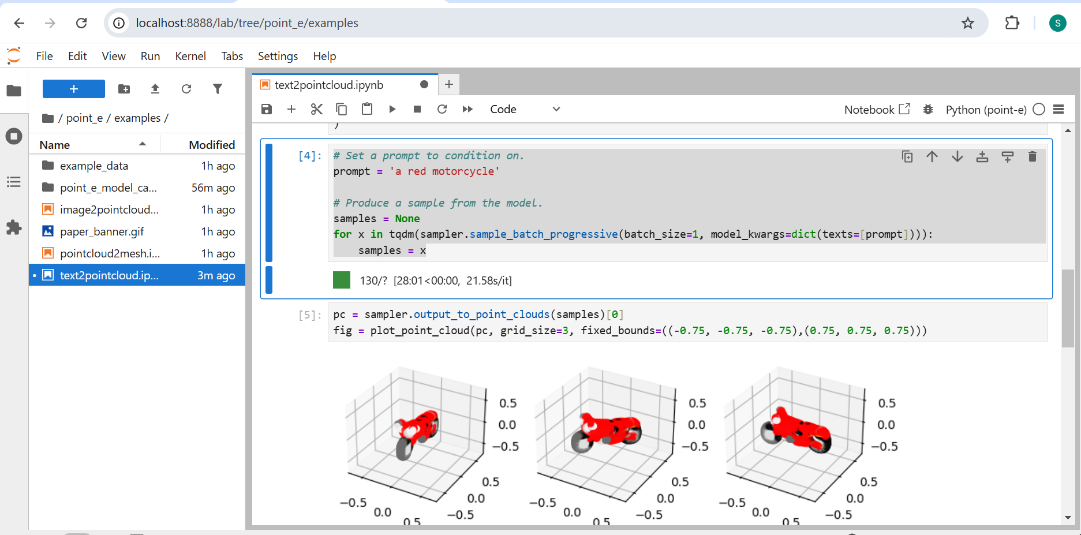
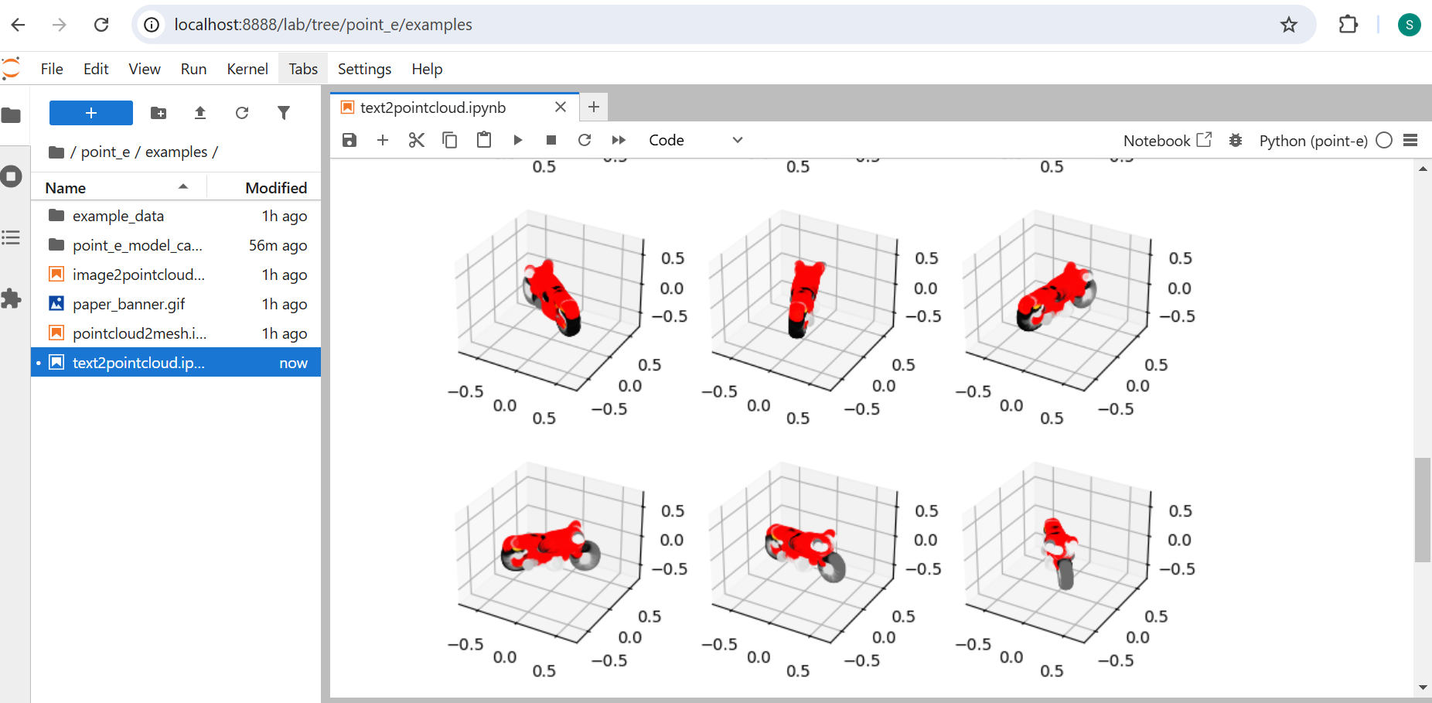

- Output Screenshots: Image-to-Point Cloud Generation
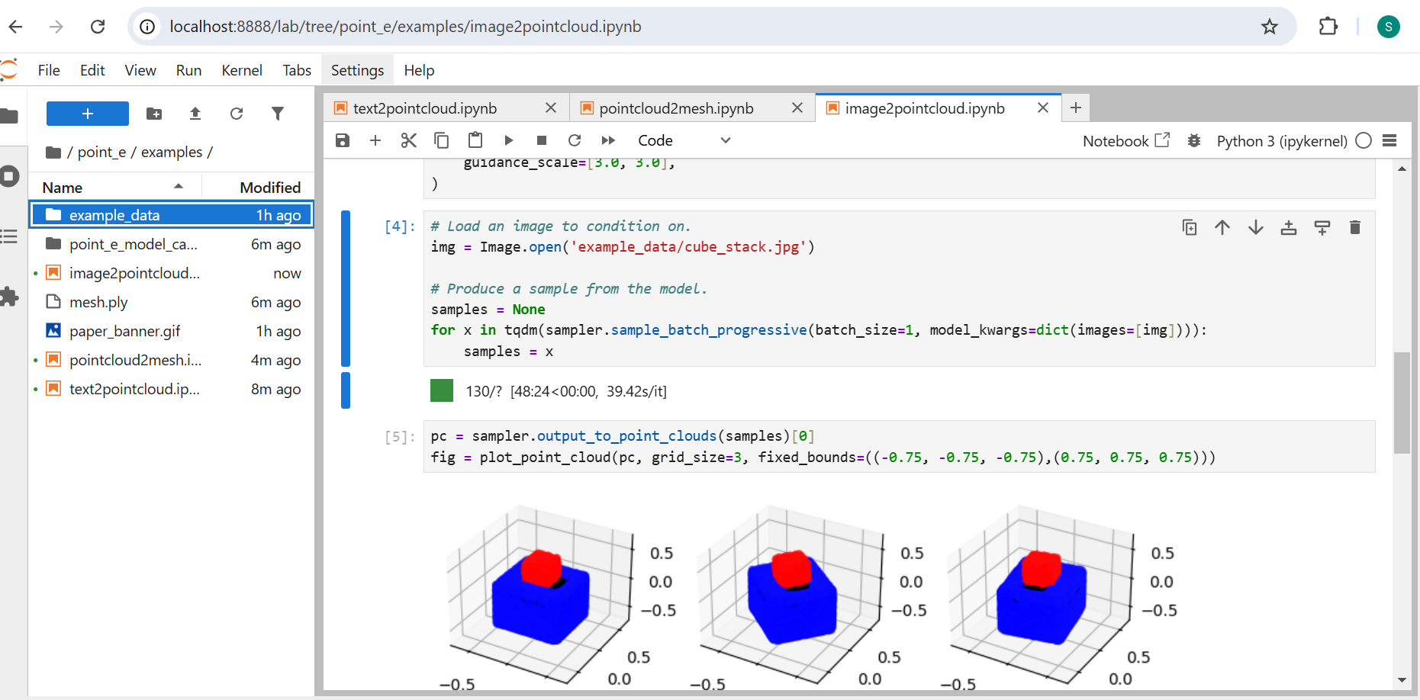

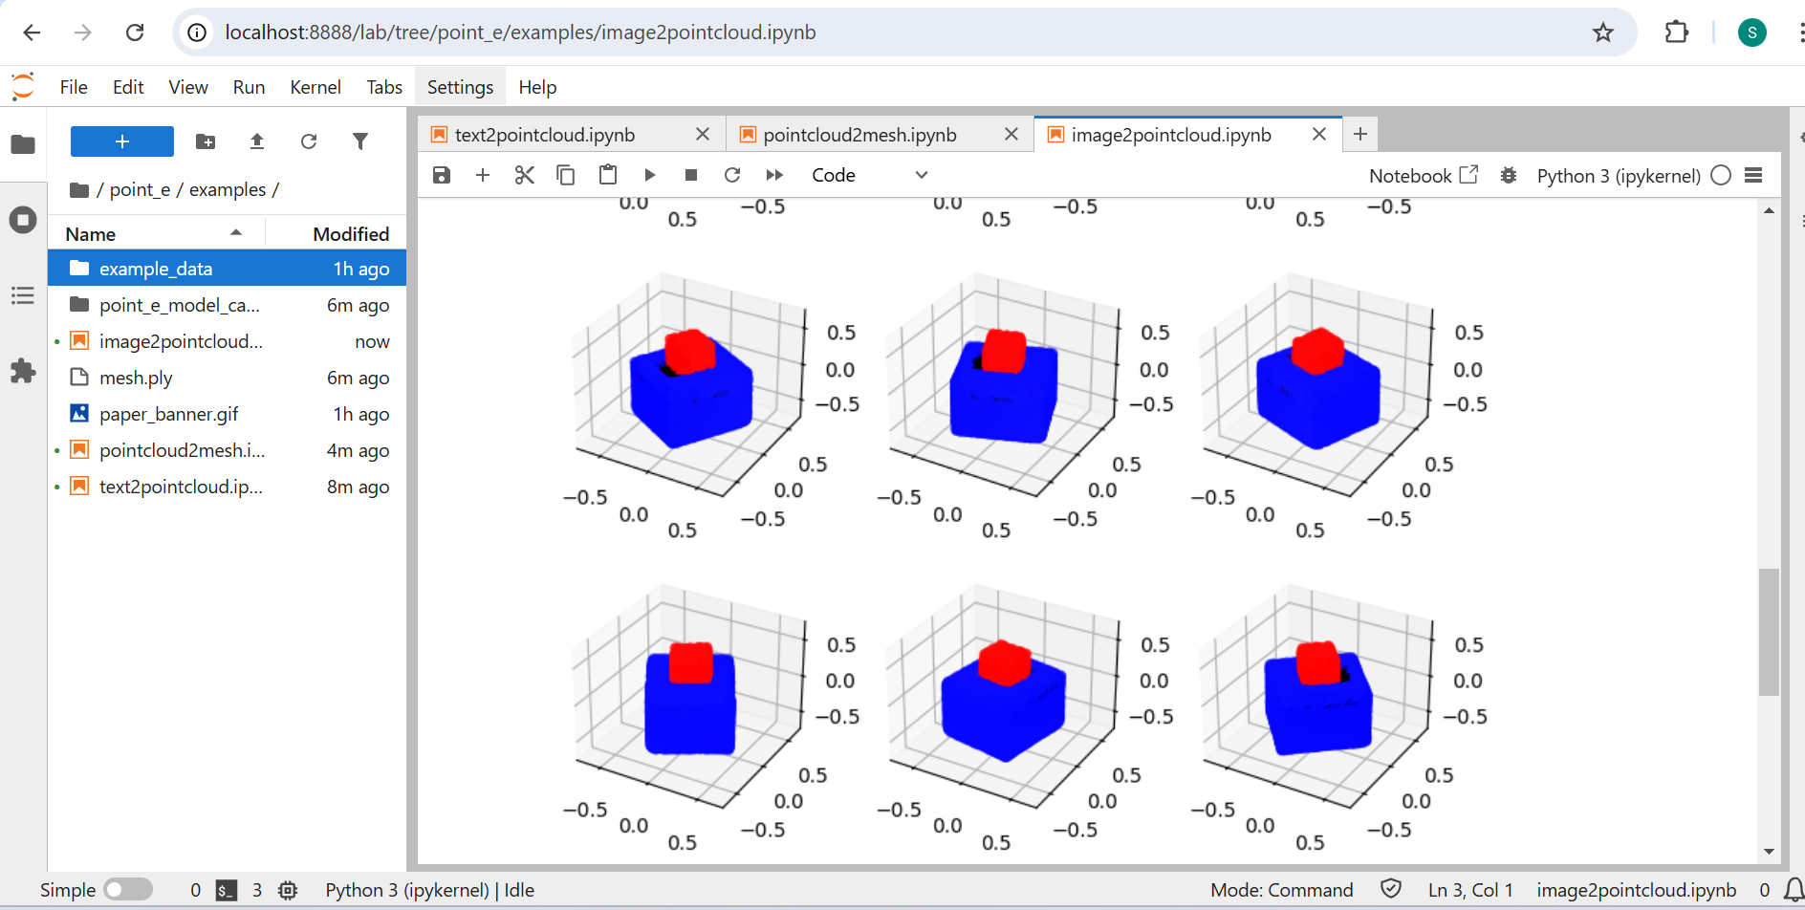

Notes and Observations
- Running on CPU significantly increased runtime.
- Model output was visually accurate and matched the input prompt.
- Next Steps:
  - Resolve GPU driver issue for improved performance.

